

UM Museum of Natural History Evolution Tour Puzzle
Purpose: Some of the best examples of evolutionary concepts, and science communication in action, are in natural history museums. Your task is to explore the UM Museum of Natural History (UMMNH) and find examples of evolutionary concepts, observe science communication strategies in action, and gain inspiration for your Evolutionary Concept graphic.

Instructions:
1 REVIEW the Evolutionary Concepts List on Canvas (also below) and select 2 evolutionary concepts you may want to define in your Evolutionary Concept graphic. Keep these in mind as you explore the museum. Canvas also contains images of exhibits throughout the museum that may be used as inspiration for your graphic.

- What Causes Extinction?
- Ages of Life
- Law of Succession
- Transitional forms
- Homologous structures
- How Do We Move?
- Convergent evolution
- Vestigial structures
- Sexual dimorphism
- Speciation
- Molecular homology
- Natural vs artificial selection
- What Can Teeth Tell Us?
- Jaws Open New Possibilities

1 EXPLORE the museum with your group and use the questions below to help guide you to key exhibits and evolutionary examples within the museum. Your responses to each question do not need to be in complete sentences but should provide a thorough answer. This self-guided tour puzzle will require you to work as a team to do some investigation and problem-solving. Be sure to look closely at specimens and read the associated information posted in the exhibits. You may also need to use the internet to help you define terms or look up information.
1 TAKE PICTURES of any relevant exhibits that you may want to use for your graphic assignment.
1 HAVE FUN & learn something new!

Any Gallery: Science Communication Questions
- Questions are powerful tools in science communication. They can be used to interrogate or draw people in. They can inspire curiosity or challenge ways of thinking.
Question: During your tour, find 3 questions the museum poses to visitors in exhibits and record them here:

Lobby (Level 1)
- Mastodons: The skeletons of the male and female mastodons provide the museum’s largest example of sexual dimorphism.
Question: What features are more pronounced on the male or the female?

Exploring Michigan (Level 1; enter next to the gift shop)
As you enter the gallery, immediately turn to your left and explore Michigan’s history (near the Mastodon partial skull).

- You will find several fossils of prehistoric mammals found in Michigan. The Law of Succession states that fossils of extinct species will resemble living organisms found in the same location.
Question: Select one prehistoric specimen and compare it to their closest modern relatives (that are alive today).

- Continue exploring this gallery with your group and you will find several examples of Science Communication including questions, storytelling, timelines, and definitions. Take a few pictures of these examples so that you can reference them while you are designing your group’s evolution graphic.

People & the Planet (Lower Level – go down the stairs to the left of the Welcome Desk)
- This gallery shows several examples of how the influence of early humans has artificially affected the evolution of some organisms.
Question: Explore this area with your group and list one example of artificial selection featured in this gallery.

- As you continue through the exhibit, find the large Bristle Mammoth skull featured near the end (you can’t miss it!).
Question: How are Bristle Mammoth fossils similar to modern day elephants (Law of Succession)?

Evolution: Life through Time (Level 2)
This large gallery explores the evolution of life on Earth through geologic time, from the first single-celled organisms through the complex forms we see today. You will spend the majority of your visit in this gallery and will find several examples of the evolutionary concepts you learned in class.

- After you take selfies with the Tyrannosaurus Rex skull, you will see a large display called “Evolution Explains It!” and a display of Galapagos Finches. These displays contain excellent examples of evolutionary concepts including molecular homology, homologous structures, convergence, speciation, artificial selection (“Superbugs”) and transitional forms. Question: Provide the title of one of these displays and their associated concept.

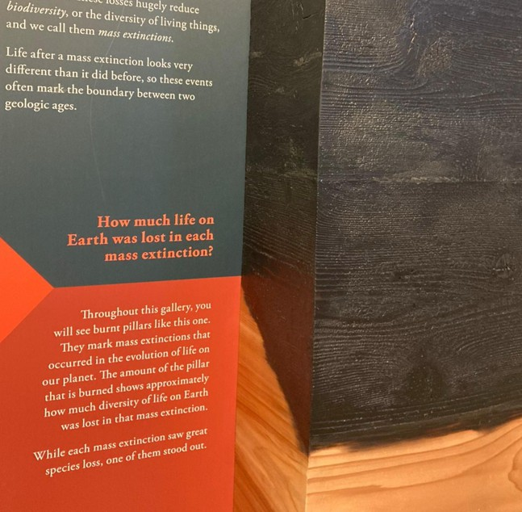
- Mass Extinction Events: Each area of this gallery represents a different time period that starts with a Mass Extinction event. The Mass Extinction events are marked by tall pillars of wood and the amount of wood that is burned represents the amount of species diversity that was lost in each event. While these mass extinctions mark an immense loss of life and biodiversity, they also greatly influence how new species evolved.

As you pass Mass Extinction 1 (end of Ordovician period), you enter a time where ancient fish
were the dominant organisms. This was an important time of big evolutionary changes, including the movement from water to land. To your left you will find fossils of Tiktaalik, a critical transitional species with an evolutionary link between water and land animals.
Question: What features did this “fishipod” evolve for being on land?

- In the exhibit What fishes did you evolve from, homologous structures in limbs of fish and humans provide evidence for the evolution of all land animals from prehistoric fish. This area also contains several fossils of early insects, crustaceans, millipedes, forests, and plants that inhabited land long before animals (hint: check out the “Earth goes green,” “Creepy Crawlies” and “Life Expands onto Land” displays). These organisms are excellent examples of transitional species, and speciation on land. They also have a lot of similarities to modern day organism (Law of Succession). Take some time to explore this area as it may provide an excellent exhibit to feature in your infographic.

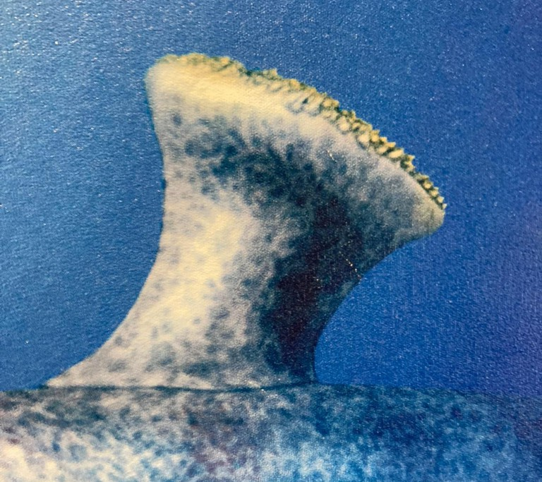
- Continue to travel passed Mass Extinction 2 (end of Devonian period) and into the time of the tetrapods (four-limbed animals) and cartilaginous fishes. On your left, check out the unusual features of some ancient sharks, and observe the early ancestors of land animals that were living a double life in the water and on land. These organisms were important transitional species. Question: Are there any anatomical features that you find odd or interesting?

- Look out the window and you will see the skeletons of prehistoric whales that lived 40 million years ago. Ancestors of Dorudon and Basilosaurus used to walk on land but later returned to the sea.
Question: What vestigial structures are evidence of this evolutionary change?

- Dimetrodon was a fierce meat-eater and Edaphosaurus ate plants, but they had similar features and are an amazing example of convergent evolution. Convergent evolution is a process by which two organisms that are not closely related independently evolve similar traits to adapt to the same environmental conditions.
Question: Name one similar feature between these two organisms.

- Meet the Survivors: As you pass Mass Extinction 3, you enter a time of transitional species, including early mammal ancestors called therapsids.

Surprising Cousins: Crocodiles are more closely related to birds than they are to lizards or other reptiles. Birds and crocodiles are part of a group called archosaurs. Desmatosuchus and Brachysuchus are common ancestors that are on display in this area. You may find an interesting transitional species to use for your project in these areas.

- Locate and observe the unknown footprint cast next to the Surprising Cousins exhibit. Scientists use footprints to determine how prehistoric animals moved. For example, did they walk on two feet (bipedal) or four feet (quadrupedal)? As you continue through the gallery, name one other example of animal prints on display in the museum.
Question: Were these animals bipeds or quadrupeds?

- Coelophysis was an important transitional species that led to the evolution of huge, meat-eating dinosaurs like T. rex (on display next to the footprint cast).
Question: How does the fossil of Coelophysis show evidence that it was a meat-eater?

- Mass Extinction 4 marked the beginning of the time of the dinosaurs and a time of exciting evolutionary changes. Both Majungasaurs (large skeleton on display) and Tyrannosaurus Rex (seen earlier in the gallery) lived during the Late Cretaceous but the two organisms lived in different regions and were distantly related. Similar lifestyles caused them to develop similar features (convergent evolution).
Question: What features does Majungasaurus share with T. rex?

- During the Triassic – Jurassic periods, animals evolved specialized structures to gather food, hunt, defend themselves, or attract mates. For your project, you may choose to select a dinosaur species of interest and describe how its specialized structures helped it to survive or reproduce by natural selection.
Question: Archaeopteryx is an important transitional link between dinosaurs and what major groups of animals?

- Not all reptiles during the Triassic – Jurassic periods were dinosaurs. As you cruise through the gallery, you will observe several species of pterosaurs (flying reptiles), ichthyosaurs (early swimming reptiles), and plesiosaurs (later swimming reptiles). Many of these species have homologous structures to species that are alive today (e.g., Platecarpus and modern whales). You may find an interesting specimen to use for your project here. (Hint: You may also want to check out the massive Quetzalcoatlus flying over the atrium as you exit the Evolution gallery!)

- As you enter the Cenozoic era near the end of the gallery, life begins to look more like modern day animals. Mammals begin to dominate and flowering plants start to spread. On display are a variety of prehistoric mammals that look very similar to species that are alive today and are important transitional forms to modern day mammals. Question: Select one of these species and name the modern day mammal that it looks like.

- The last area of the gallery features the evolution of humans. One of the best examples of speciation can be found in our own family tree. Looking at the fossils in this exhibit (especially the skulls) observe some of the structural and functional features that changed over time to create Homo sapiens.

Under the Microscope
Perhaps one of the strongest pieces of evidence for evolution is the molecular homology of all living things on earth. All forms of life start with the same basic components. This exhibit has several examples of how different species are similar at the molecular and microscopic levels.

- As you enter the exhibit, the wall on your left contains a long display explaining how all of life on Earth is related. For your project, you may choose to use one piece of molecular homology that proves all of life is related (several are described in this display).

- On the opposite side of the exhibit are two displays called “Every Body Grows” and “Common Processes.” These displays show the distinct similarities in development among vertebrates and is a key piece of evidence of the common ancestry of all animals. During embryonic development, similar cells have evolved to form different parts in different organisms. The same cells that develop into jaws in fish develop into the ear bones in humans.

The interactive table below shows the 5 stages of embryonic development of a human, fish, mouse, and chicken. As you explore this display, select two of the species and compare and contrast their development.
Question: Which two species did you choose and at what stage do the species start to look different?

- Behind you is a display called “Why we don’t look like mushrooms.” Question: What are homeobox genes?

Make sure you take time to explore the interactive displays in this gallery such as peeking inside the cell, building a hemoglobin protein, or completing a DNA strand!

